Software Requirements Specification

**Transaction management system**

1. **Introduction**

This section gives a scope description and overview of everything included in this SRS document. Also, the purpose for this document is described and a list of abbreviations and definitions is provided.

* 1. Purpose

The purpose of this document is to give a detailed description of the requirements for the “Transaction management system” (TMS) software. It will illustrate the purpose and complete declaration for the development of system. It will also explain system constraints, interface and interactions with other external applications. This document is primarily intended to be proposed to a customer for its approval and a reference for developing the first version of the system for the development team.

* 1. Scope

The “Transaction management system” (TMS) is a web application which helps people to find and change information about their accounts, perform transactions (transfers and payments), view their accounts summary based on each user. The application should be easy to use from any web connection and for anyone who already has an account. All system information is maintained in a database, which is located on a web-server.

1. **Overall description**

This section will give an overview of the whole system. The system will be explained in its context to show how the system interacts with other systems and introduce the basic functionality of it.

* 1. Product perspective

This system will consist of a web portal, used for managing the information about the users accounts and the system as a whole.

Since this is a data-centric product, it will need somewhere to store the data. For that, a database will be used. The web portal will communicate with the database, being able to add and modify data. All of the database communication will go over the Internet.

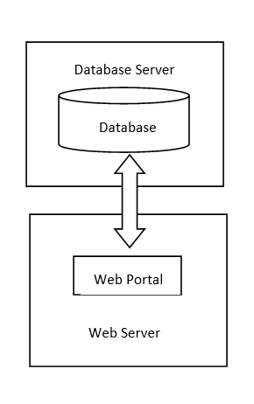

Figure 1 Block Diagram

* 1. Product functions

The web portal will provide functionality to manage the users account, password change, transfers, transactions history.

1. **Specific requirements**

This section contains all of the functional and quality requirements of the system. It gives a detailed description of the system and all its features.

* 1. User interfaces

The user of the web application should see the log-in page when they open the application. If the user has not registered, he/she should be able to do that on the log-in page. Here the user fills in their email address as well as a password. The required information in order to configure the user’s profile shall be updated after register phase – Figure 10.

If the user is not a first-time user, he/she should be able to sign in with their email and password – Figure 9.

Every user shall have a home page where they can see the balance of their accounts, and their card limits- see Figure 8. Also, the user shall be able to convert into other currencies that are available.

Users shall be able to transfer amount of money to other accounts of their own, or to other users accounts using the selected currency. If the data entered is valid, the operation will succeed - see Figure 2,3.

Every user shall choose from the services tab to pay various bills, services such as phone credit, car vignette - see Figure 4. A confirmation shall be received if the transaction was successfully performed.

The account and personal information such as first and last name, address, password, email address, phone number, bank accounts IDs, credit limits shall be configured at any moment the user want, by navigating to the Profile view and choosing between the 2 tabs – see Figure 5,6

The transactions history shall be easily viewed for a maximum period of 2 months with details regarding every transfer in or out of the account(s) – see Figure 7

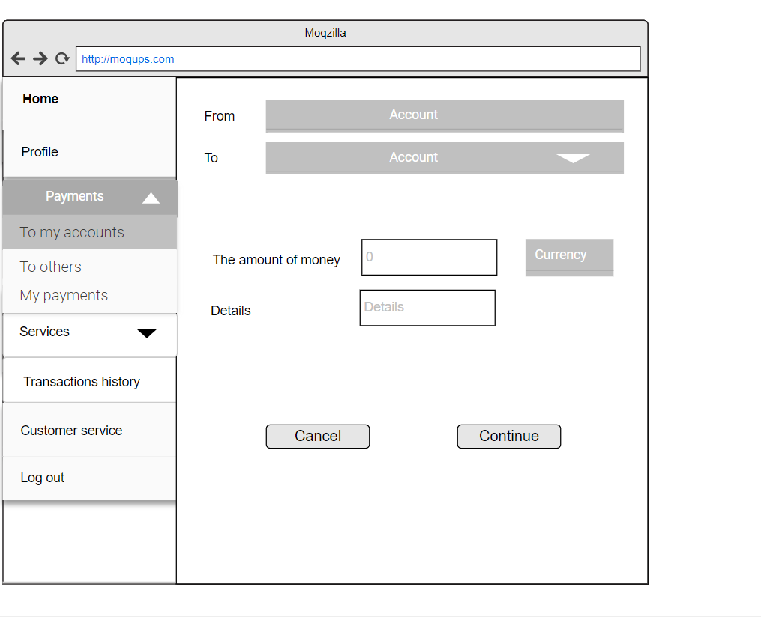

Figure 2– Payments to own accounts view

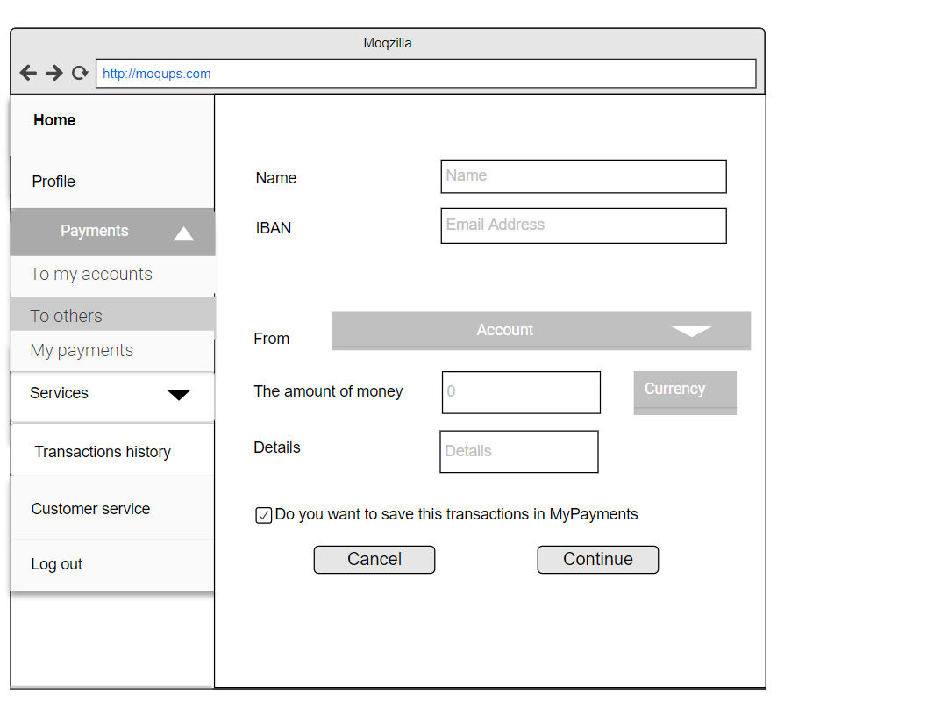

Figure – Payments to own accounts view

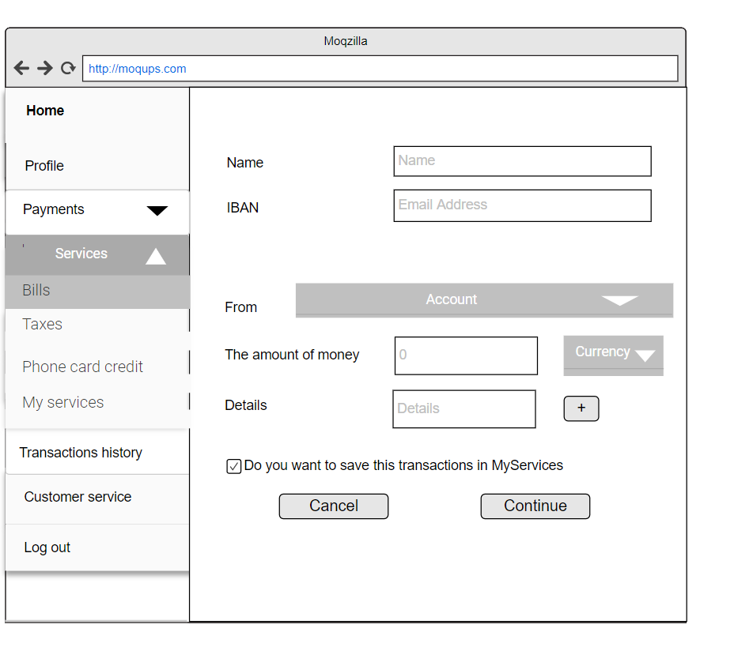

Figure 4 - Services view

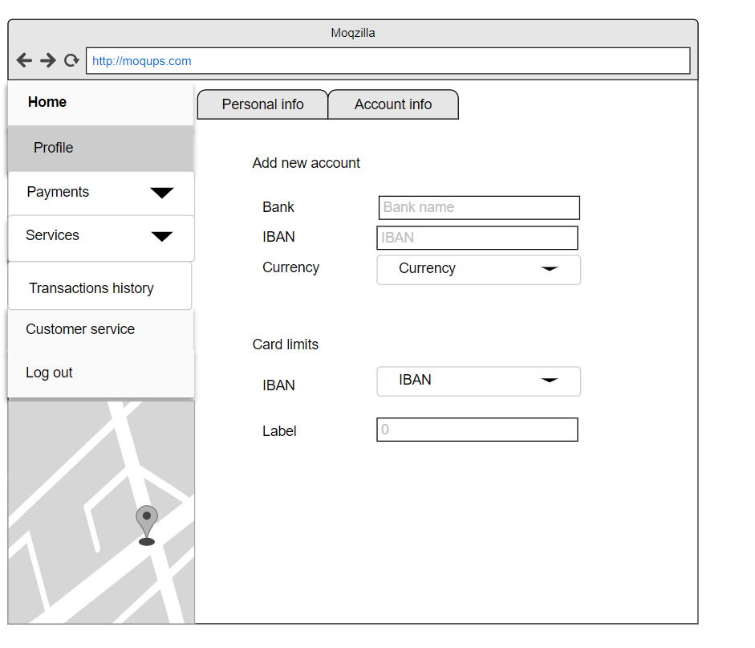

Figure 5 – Profile – account info - view

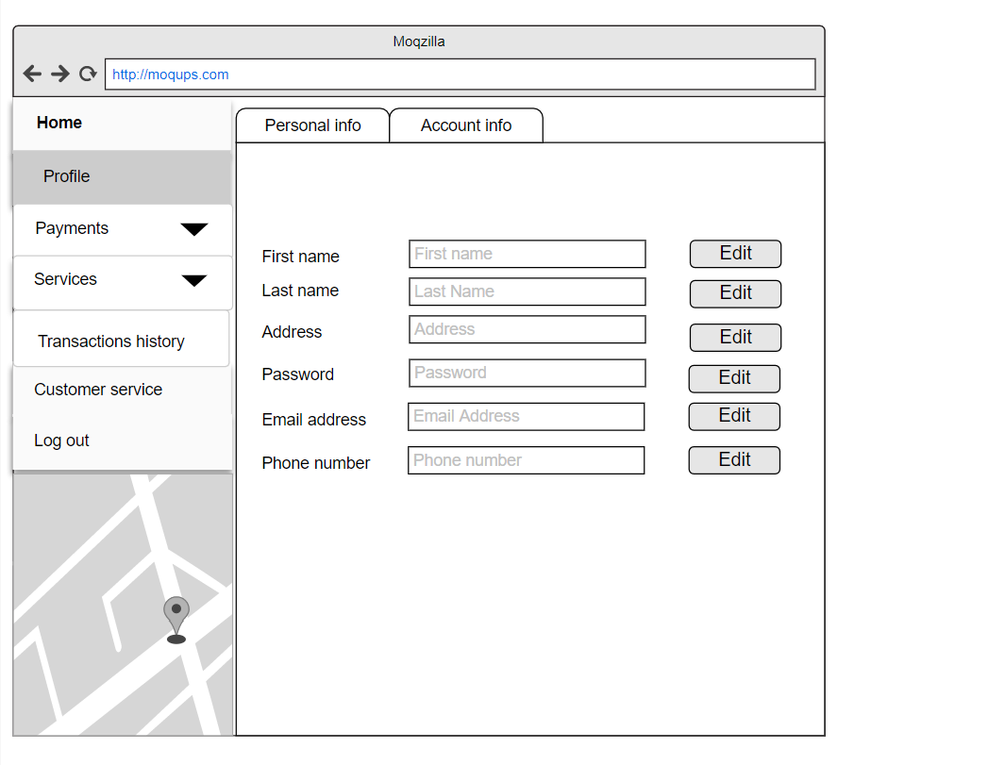

Figure 6 - Profile -personal info -view

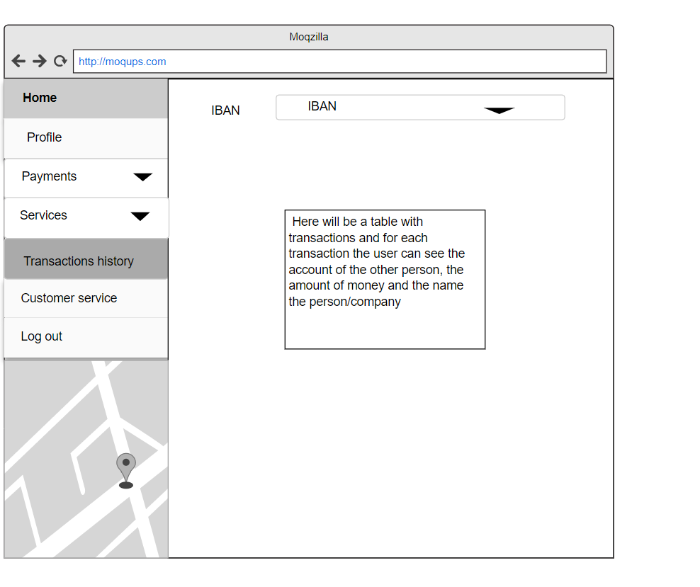

Figure 7 - Transactions history

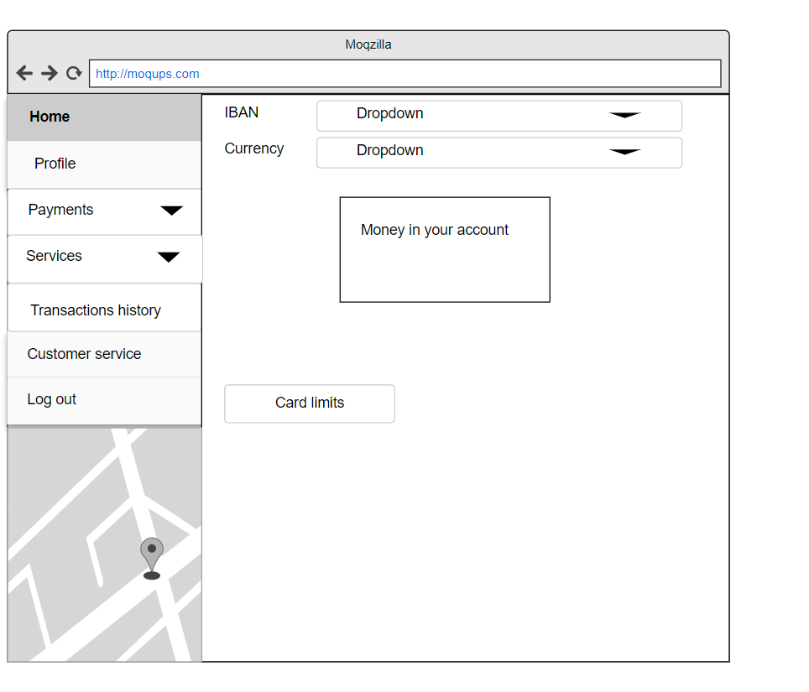

Figure 8 - Home view

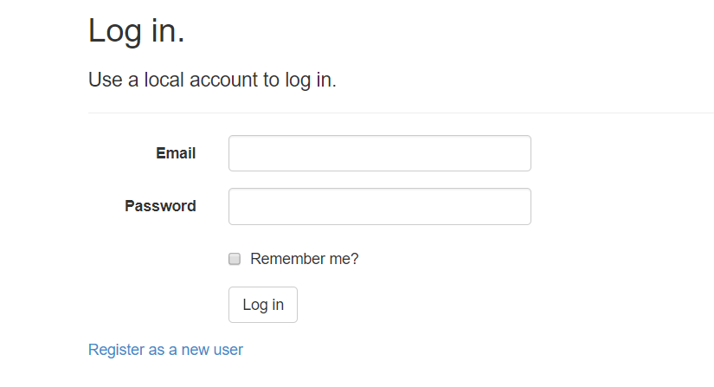

Figure - Login view

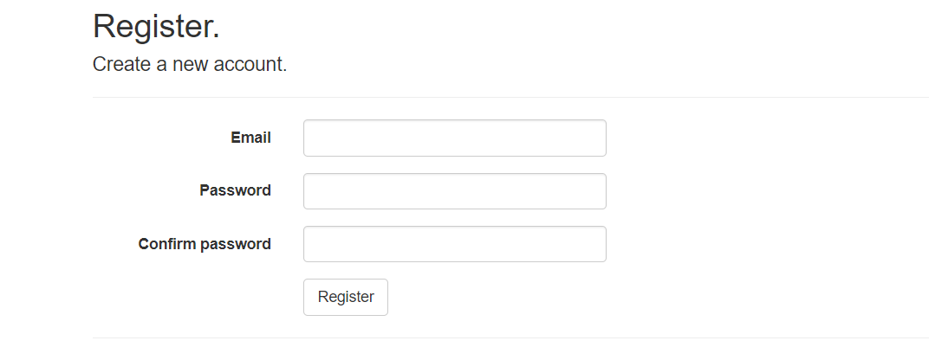

Figure -Register view

3.2.1Functional requirements for unregistered user

*ID*: FR 1

*TITLE*: User register-in - Web application

*DESC*: Given that a user has not registered, then the user should be able to register to the web application, by filling in with their personal information, at least one valid account number and enter a password that they must re-enter at every sign-in.

*RAT*: In order for a user to register on the web application.

*ID*: FR 2

*TITLE*: User see information

*DESC*: Given that a user has not registered, then the user should be able to see some information about the web application including information about admin contact.

*RAT*: In order for a user to get to know the web application.

3.2.2 Functional requirements for registered user

*ID:* FR 3

*TITLE*: User login - Web application

*DESC*: Given that a user has registered, then the user should be able to log in to the web application. The user can sign in with their email and correct password.

*RAT*: In order for a user to login on the web application.

*ID*: FR4

*TITLE*: Recover password

*DESC*: The user should be able to recover his/her password by requesting an email containing a 6 digits code that they must enter. If the code is valid, the password must be updated.

*RAT*: In order for a user to recover his/her password.

*ID*: FR5

*TITLE*: Edit and view profile information

*DESC*: The user should be able to view or edit his/her personal information: password, address,e-mail address, phone number, first name, last name

*RAT*: In order for a user to edit or viewhis/her personal information.

*ID*: FR7

*TITLE*: Add new account

*DESC*: The user should be able to add a new account number for which they have to configure a low limit and the currency .

*RAT*: In order for a user to edit or viewhis/her accounts.

*ID*: FR8

*TITLE*: Services-bils

*DESC*: The user should be able to make payments for : various home bills, by filling in the required account numbers or bills IDs and the amount of money that are needed.

*RAT*: In order for a user to pay his/her services and bills.

*ID*: FR9

*TITLE*: Services-credit card charge

*DESC*: The user should be able to make payments for : phone card credit, by choosing the mobile network, amount of credit, filling in the information of the person(name, phone number, email address), choose from which account to wire.

*RAT*: In order for a user to charge a phone with credit.

*ID*: FR10

*TITLE*: Services-pay taxes

*DESC*: The user should be able to make payments for : some taxes, like vignetta. First the user has to choose the type of the car. Second the period of time that he/she can use it. The he/she has to choose from which account to wire and fill the information about the car.

*RAT*: In order for a user to pay taxes.

*ID*: FR11

*TITLE*: Services-my services

*DESC*: The user should be able to save the services he/she uses and the next time he/she will use them, he/she will just fill some additional information.

*RAT*: In order for a user to contorize their services.

*ID*: FR12

*TITLE*: Payments-to me

*DESC*: The user should be able to transfer amount of money between their different accounts in different currencies by choosing the account and the currency.

*RAT*: In order for a user to transfer his/her money in his/her own accounts.

*ID*: FR13

*TITLE*: Payments-to others

*DESC*: The user should be able to transfer amount of money to another user’s account, in different currencies by filling in the other user information.

*RAT*: In order for a user to transfer his/her money to other users.

*ID*: FR14

*TITLE*: Payments- my payments

*DESC*: The user should be able to save the payments he/she uses and the next time he/she will use them. He/She will just fill some additional information.

*RAT*: In order for a user to contorize their payments.

*ID*: FR15

TITLE: Transactions history

*DESC*: The user should be able to choose and see the tranzactions history for every account they own.

*RAT*: In order for a user to view their transaction history.

*ID*: FR16

*TITLE*: Customer services

DESC: User is able to send to a bank employee a message describing their problem and view a list of FAQs that might solve their issues and view the daily various currency change rate.

*RAT*: In order to help the user deal with navigating on the application.

*ID*: FR17

*TITLE*: ATM locations

*DESC*: User is able to view at all times on the home page a map where they can locate ATMs, as well as bank branches .

*RAT*: In order to help the user deal with navigating on the application.

*ID*: FR18

*TITLE*: Logout

*DESC*: User is able to logout from his/her account.

*RAT*: In order to exit the application.

*ID*: FR19

*TITLE*: Loan simulator

*DESC*: User is able to simulate a loan by filling in the desired amount of money and the time he/she wants to pay and he/she should see the amount of money he/she should pay monthly.

*RAT*: In order to simulate a loan.

*ID*: FR20

*TITLE*: Currency converter

*DESC*: User is able to convert a sum of money in different currencies with the current value of that currency, also the user should be able to see the currency change rate.

*RAT*: In order to convert money.

*ID*: FR21

*TITLE*: Currency converter

*DESC*: User is able to convert a sum of money in different currencies with the current value of that currency, also the user should be able to see the currency change rate.

*RAT*: In order to convert money.

3.2.2 Functional requirements for admin user

*ID:* FR 22

*TITLE*: Admin login - Web application

*DESC*: The admin has an predifined account and he/she can sign in with their email and correct password.

*RAT*: In order for an admin to login on the web application.

*ID:* FR 23

*TITLE*: Admin vizualisation

*DESC*: The admin can see a list with the active users, but he/she doesn’t have access to their transactions or activity .

*RAT*: In order for an admin to supervize the users.

*ID:* FR 24

*TITLE*: Admin activate/deactivate clients

*DESC*: In some cases the admin must deactivate a user(the user will not be able to access the account but it is not deleted). And also to activate again after the problem is solved.

*RAT*: In order for an admin to activate/deactivate users.

*ID:* FR 25

*TITLE*: Manually change a password

*DESC*: The admin can change a password if there are problems with the forgot your password functionality or if the user asks for it.

*RAT*: In order for an admin to change a password.

1. Use case diagrams for Transaction management system

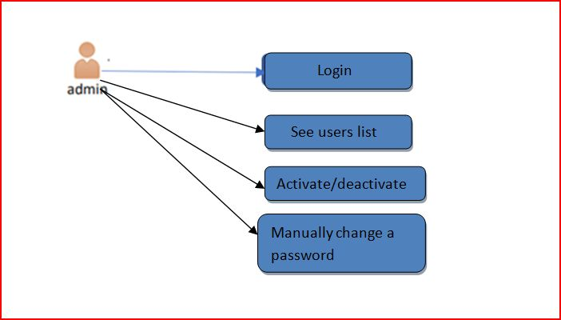

Admin use case diagram

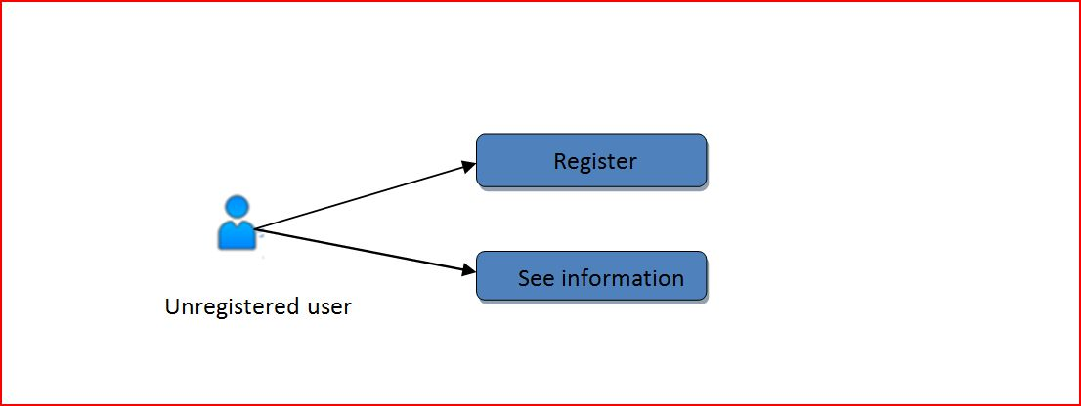

Unregistered user use case diagram

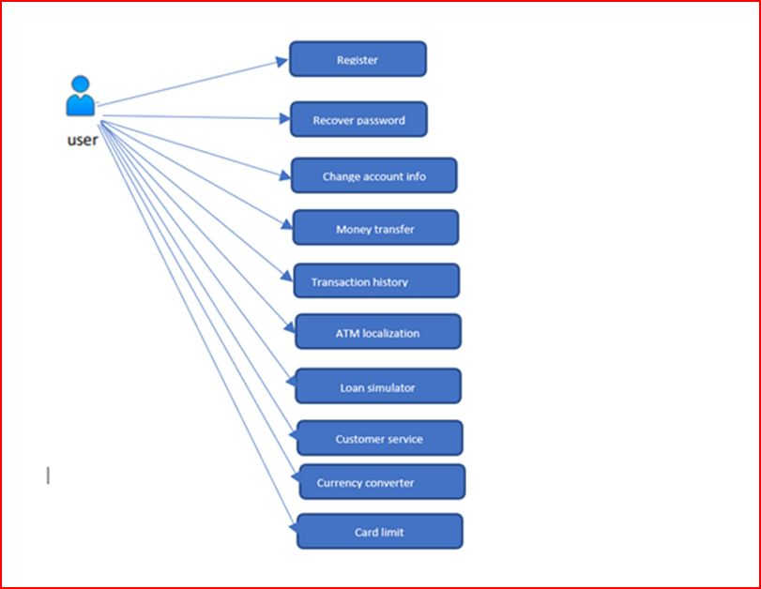

Registered user use case diagram

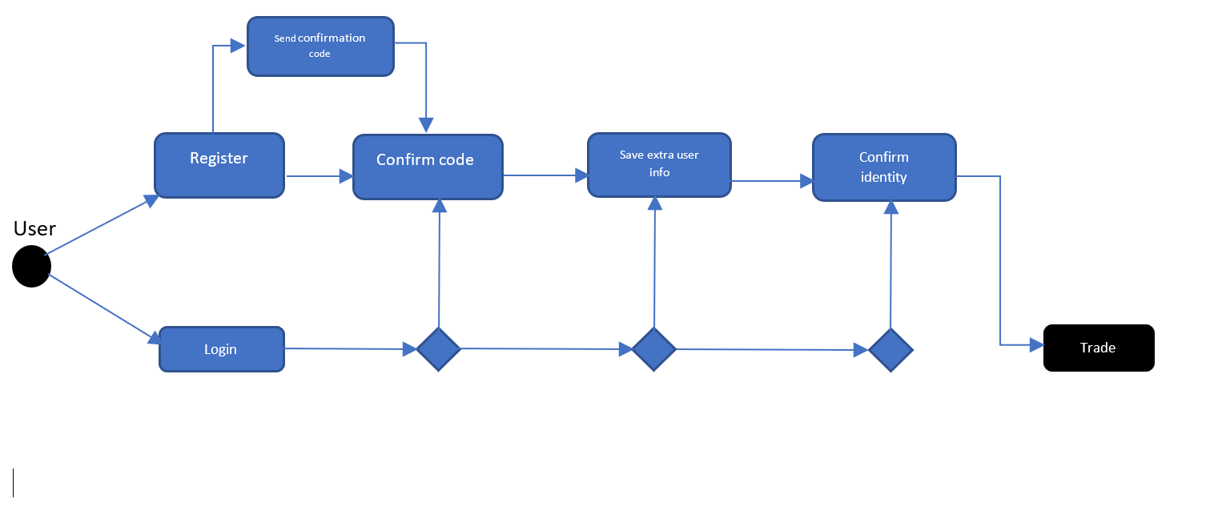Login diagram

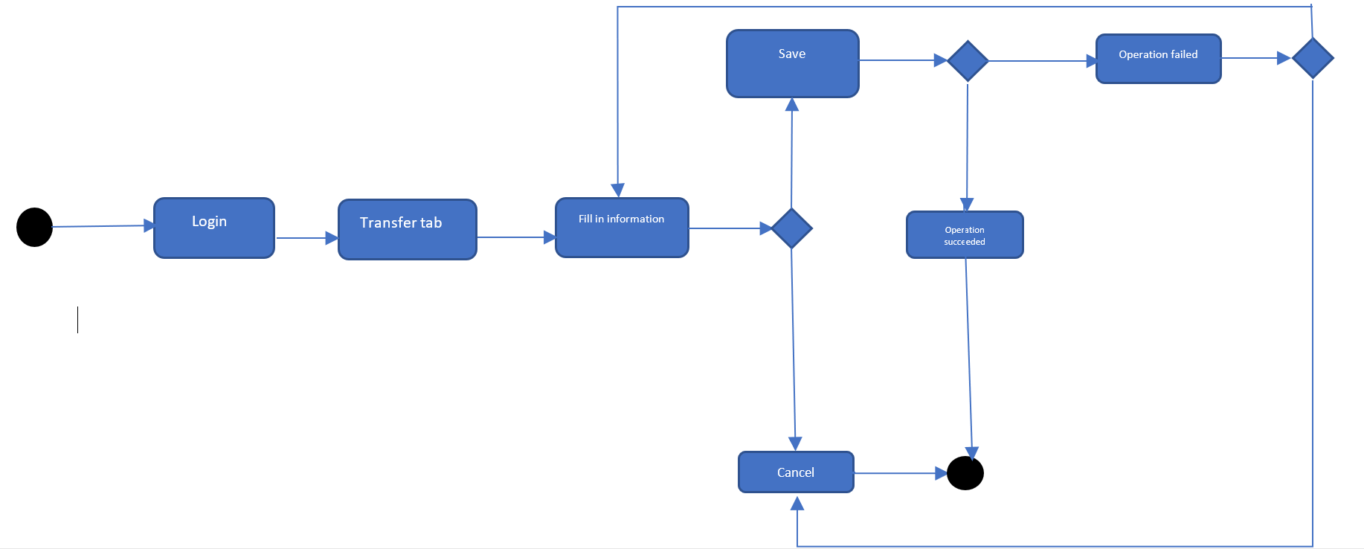

Transfer diagram